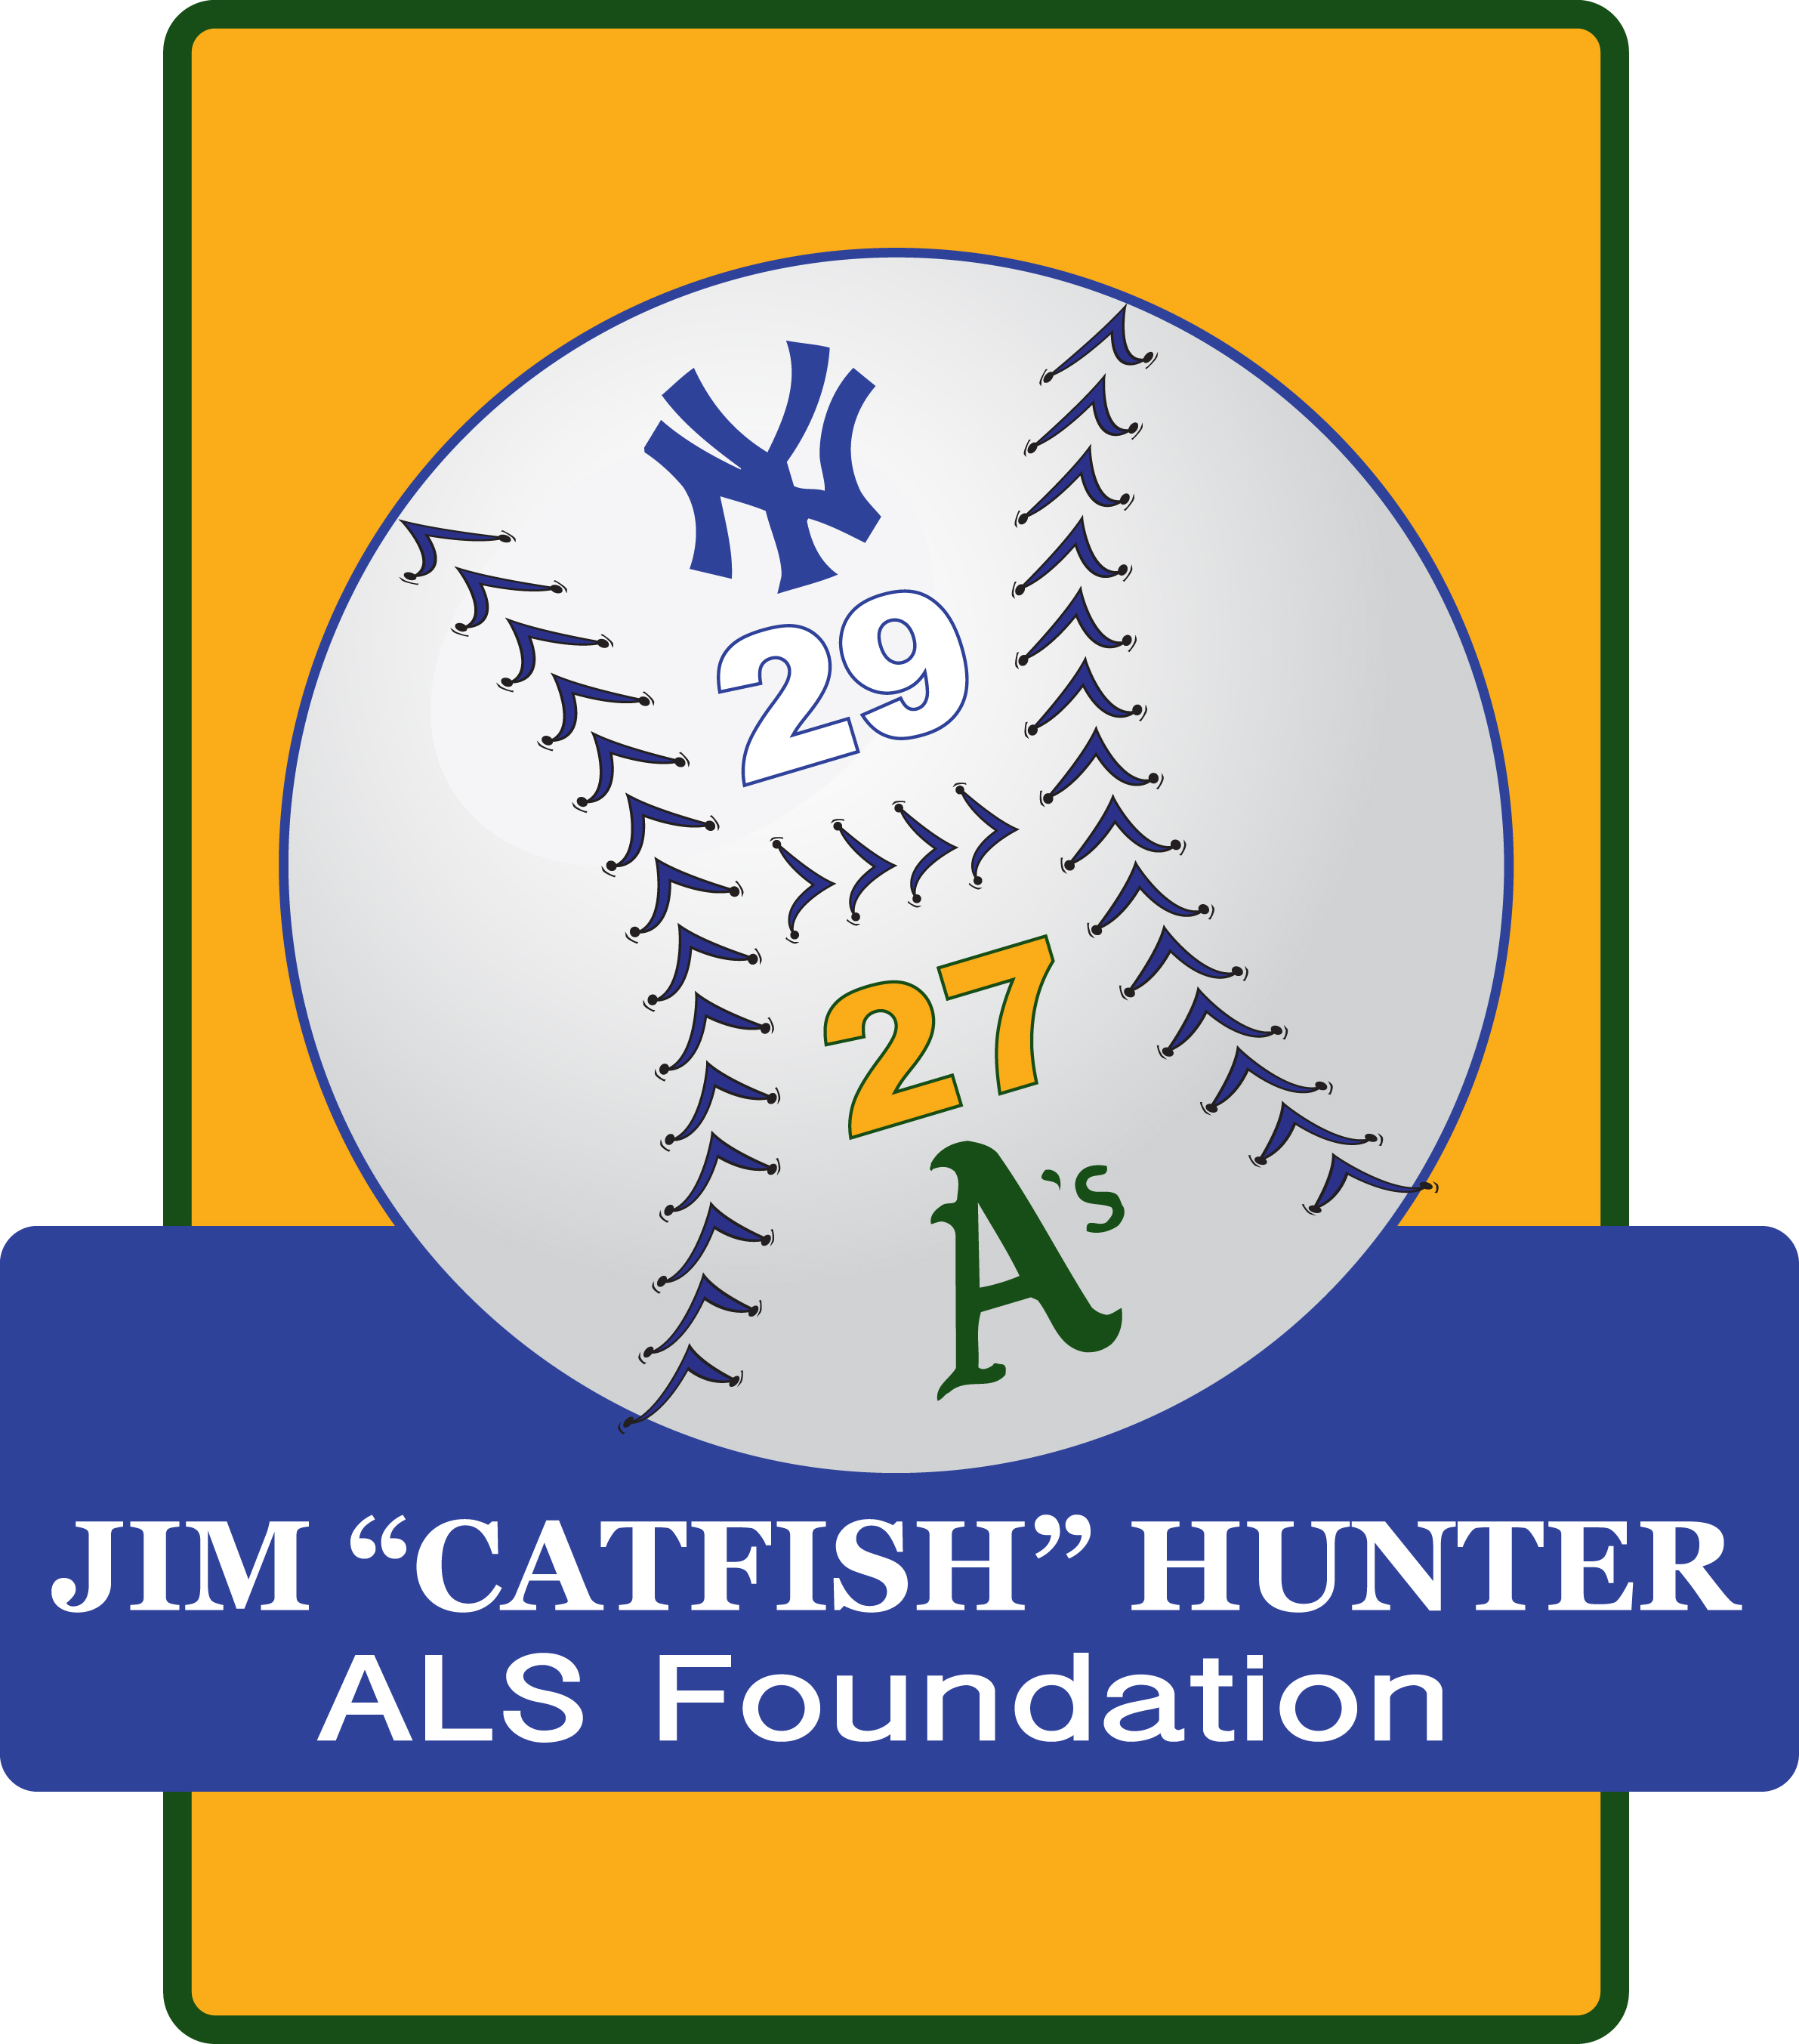
Jim “Catfish” Hunter ALS Foundation
Grant Application

This grant application is intended to assist persons living with ALS (PALS) and/ or caregivers providing for PALS. The grant is intended to help with medical expenses, medical equipment, respite care, travel, or other needs PALS may have.

Grant Application Process
- Please fill out the complete application. Once the application is received, you will receive notification of receipt. It will be reviewed by the Foundation’s Board of Directors. Please allow 1 month for review and approval.
- Possible Grant uses may include, but are not limited to:
  - Medical/ Pharmaceutical Expenses
  - Home Health Assistance
  - Travel Costs
  - Home and Auto Modifications
  - Medical Equipment/ Supplies
- Funding of all grants will be based on need and available resources. If the full amount cannot be funded, the Foundation will work with the patient and caregiver to assist in the best way possible.
- Once your grant application is approved, the Foundation will ask for a bill or invoice and will pay the bill directly to the provider. If the bill has already been paid, proof of payment will be requested and the grant recipient will be refunded.
Please make sure your application is signed and dated when submitted.
Mail or Fax the Application to the Foundation at:
The Jim “Catfish” Hunter ALS Foundation
PO Box 47
Hertford, NC 27944
Fax: 252-337-7922

Questions or Comments? Please contact:
Tommy Harrell – 252-426-5145; Helen Hunter – 252-426-7998; Ashley Stoop – 252-312-4952

Grant Application

Date: __________________________

PALS Information:

Name:
Physical Address:
City: | State: | Zip:
Mailing Address (if different from Physical Address):
City: | State: | Zip:
Home Phone: | Cell Phone:
Email Address:
ALS Clinic Name: | Neurologist Name:
Date of Diagnosis: | Date of Birth:
Grant Amount Requested:
What will this grant funding be used for?

Primary Caregiver Information:

Name:
Address:
City: | State: | Zip:
Home Phone: | Cell Phone:
Email Address:
Relationship to Patient:

I understand Foundation grants are intended for use by those who truly need financial assistance. To the best of my knowledge and belief, the information I provided above is true, correct, and complete.

_____________________________________________________ ________________________
Applicant – Patient or Caregiver (Print Name) Date

_____________________________________________________ ________________________
Signature Relationship to Patient

